**OneDrive Bully v.1.3.0.0 – Manual (19/02/2021)**

# Symbolic Links – What is it?

Symbolic Links are a standard Windows feature to create links to folders. For example, let’s say you have a folder in “C:\My Folder\” and you want that to be also accessible from “D:\My Folder\”. You don’t want to maintain your files in the folders twice.

You can create a Symbolic Link in “D:\My Folder” to point to your “C:\My Folder\”. After you create it, you can access the files either by visiting either “C:\My Folder\” or “D:\My Folder\” and you will see the same files. That is because the files exist only in the “C:\My Folder” and you consume disk space only once, isn’t great? If you create a new file, delete an existing one, modify one, the change will be visible from both locations.

# Symbolic Links and OneDrive Issue

By Using any tool available online or by using Command Prompt, you can create a Symbolic Link in Windows. That means that you could create one in OneDrive root folder. The problem is that OneDrive will not track the changes in the files of the original folder and will not sync them to the cloud. That is probably because Windows don’t forward folder events to Symbolic Link target folders.

# How OneDrive Bully solves this issue

The solution to the above is this application. It allows you to easily create the Symbolic Link of your folders in OneDrive root folder and will trigger OneDrive to sync any changes to the original files/folders to the cloud.

The trick to do the above is pretty simple. It will create a temporary 0 kb text file named “OneDriveBully_SyncTempFile.txt” in the root folder and then delete it after 5 seconds. That will trigger OneDrive to check for file/folder changes in all folders (and Symbolic Links) appearing in the root folder.

# OneDrive Bully Interface

## Installation

Run the installer and click Next till the end. You don’t need to change any settings.

Once the installer finishes, close it.

Open OneDrive Bully from Windows Start Menu. If you want to setup your Symbolic Links, please run the application as administrator.

To run the application as Administrator open Windows Start Menu, find OneDrive Bully, right-click and click on More, “Run as administrator”

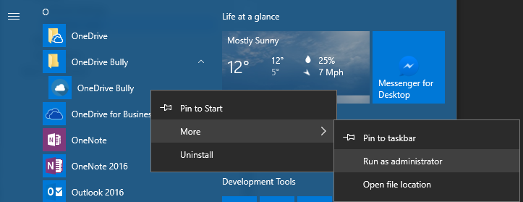

The first time you run the application, the Settings Form will pop-up.

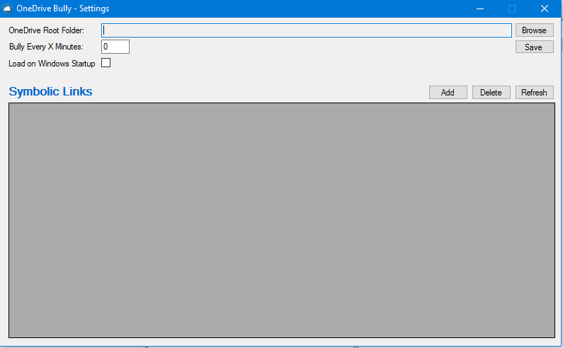

Follow the instructions in the next section “Settings”.

## Settings

You can change your settings by right-click on the taskbar icon and then click the Settings Menu

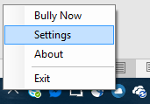

The Settings Form will open.

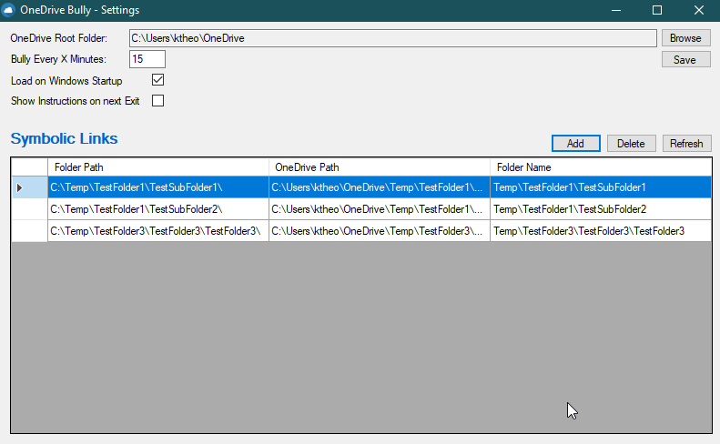

### General Settings

**OneDrive Root Folder**: You can use the Browse button to select your OneDrive root folder.

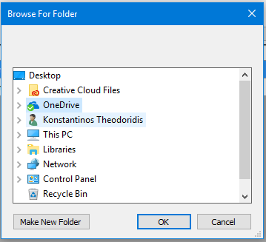

**Bully Every X Minutes**: Set the timer interval in minutes. For example, if you want to trigger OneDrive once per hour, set the value to 60.

**Load on Windows Startup**: If you set this value to Yes (ticked) it will create a Windows Registry entry (in SOFTWARE\Microsoft\Windows\CurrentVersion\Run) and the application will start with your Windows. If you change the value to No (unticked) it will delete the previously created entry.

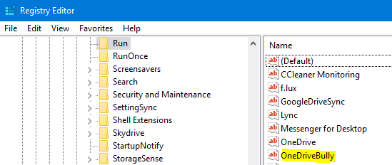

All your settings are saved in C:\username\AppData\Local\K.Theodoridis\OneDriveBully.. folder.

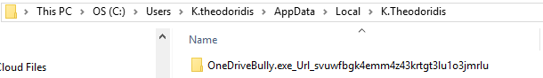

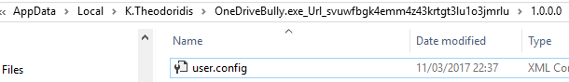

The user.config file is an XML file with all the values you set in the Settings Form.

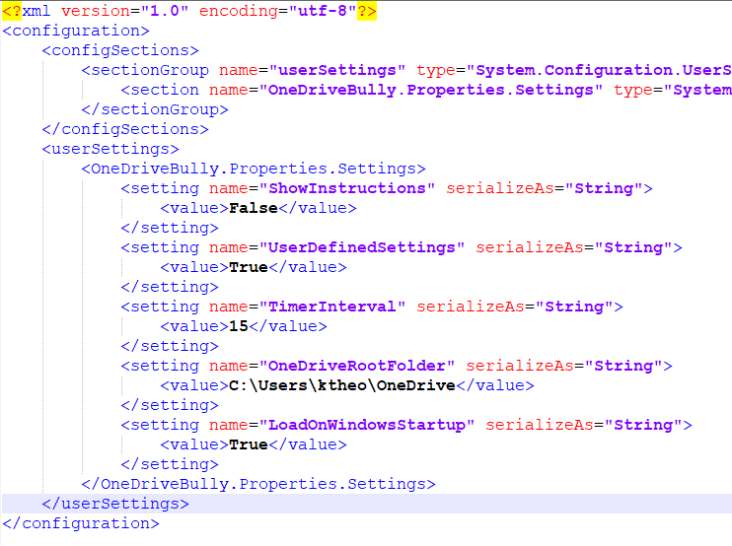

### Symbolic Links

To create new Symbolic Links, you need to run the application as Administrator. To do this, close the current application (if running) and open Windows Start Menu, find OneDrive Bully, right-click and click on More, “Run as administrator”



If you are not running the application as administrator, you will receive an Error message.

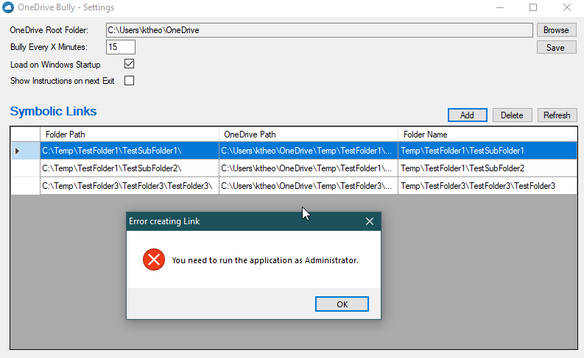

Open the Settings Form and click on **Add** button. A Folder Browser will open up to select the folder you want to create a Symbolic Link for in the OneDrive root folder.

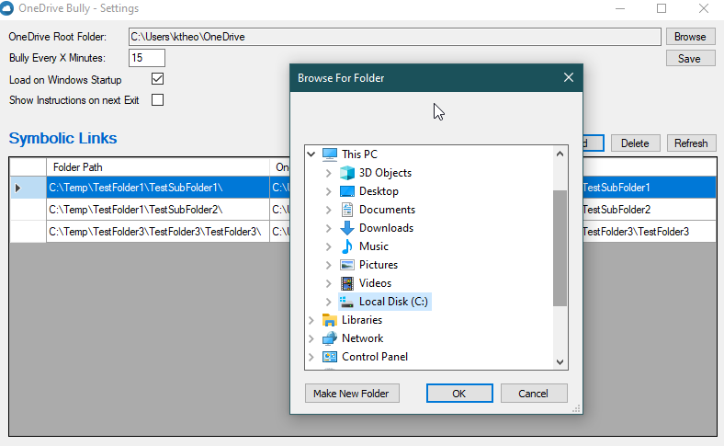

Click OK and if there isn’t any error, like the folder already existed in OneDrive root folder) the application will create the Symbolic Link for you.

**Case Example:**

I have a folder in my work pc in “C:\Temp\” called “My Test Folder”. I want to sync this folder to OneDrive but I don’t want to have a copy of all the files in two folders. I will create a Symbolic Link of this folder.

**In OneDrive website, I can see that I haven’t already created this folder:**

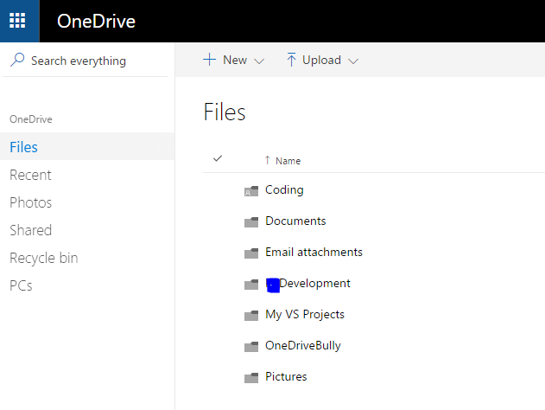

**This my original “C:\Temp\My Test Folder\” :**

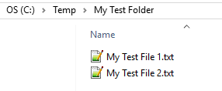

**This is my OneDrive folder:**

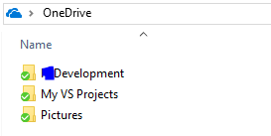

**In the OneDrive Bully Settings Form (Running as administrator) I will create the Symbolic Link:**

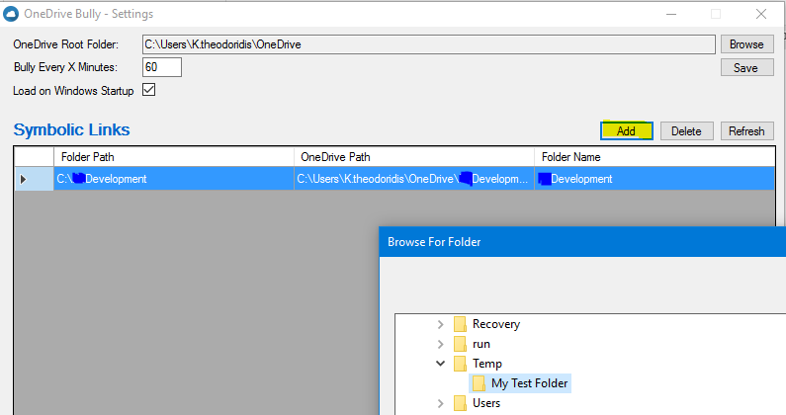

**After clicking OK on the Browser Window, the application will create the Symbolic Link and show it in the list of Symbolic Links:**

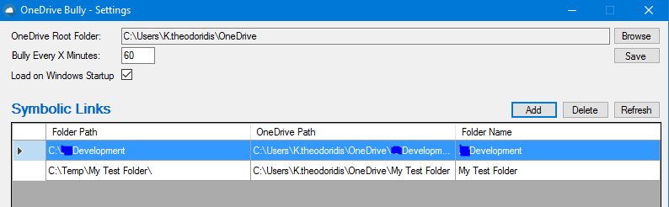

**Now if we check the OneDrive folder in the pc we will see that the new folder (fake folder it is actually a link to the original folder) has been created:**

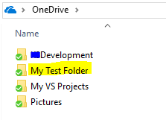

**If we double-click on the application icon or let it run on timer, once it has run you will see your new folder on the OneDrive website:**

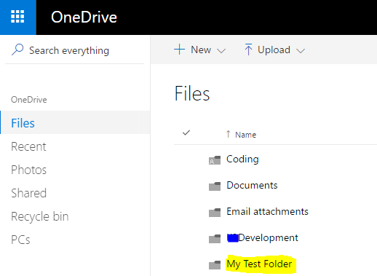

**And my files are there:**

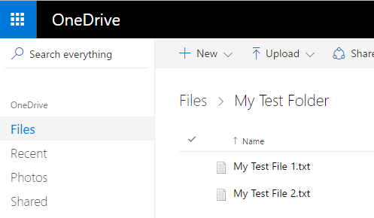

**If I want to sync this folder to my home pc, I need to create a folder with the exact same name anywhere I want.**

**In my home pc, I will follow the above procedure again.**

**Let’s say I want to have this folder in my D:\ drive.**

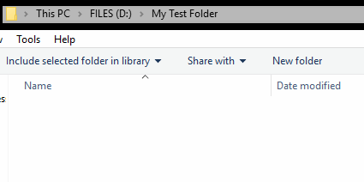

**If you have set OneDrive to sync all folders, you need to first untick the new folder from the OneDrive settings:**

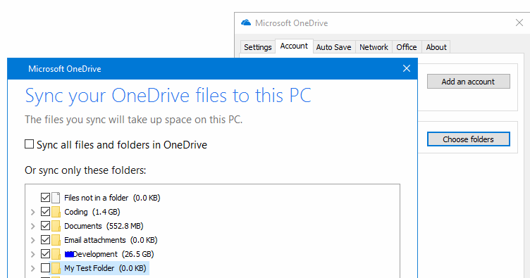

**You can confirm that you don’t have the new folder in your OneDrive folder:**

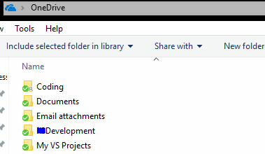

**Once you are set with the above, you can create the Symbolic Link to your “D:\My Test Folder” by opening OneDrive Bully Settings Form and following the above instructions we used for the work pc.**

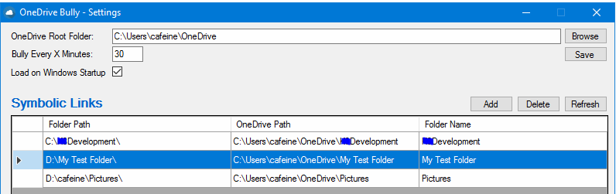

**If you check your OneDrive folder you will see that OneDrive is complaining about the new folder:**

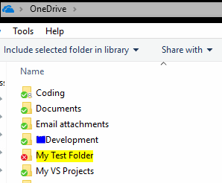

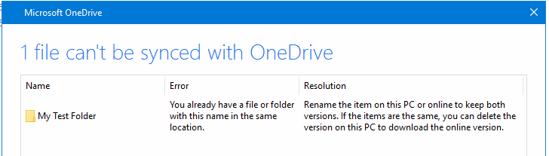

**To fix this, you need to open OneDrive settings as before and tick the new folder to sync:**

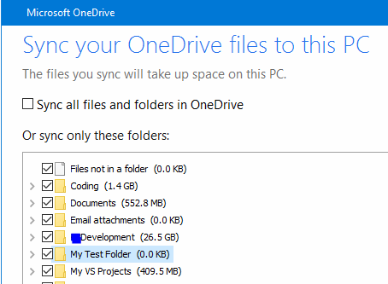

**After doing the above, OneDrive will be able to sync correctly your new folder and files:**

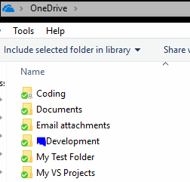

**If you check your new folder, it will have the files you had created in the beginning:**

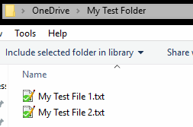

**And if we check the actual folder in “D:\My Test Folder\” we will see the same files:**

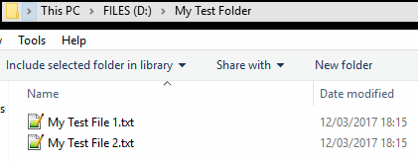

**That’s it. From now on, whenever you make a change in the files in this folder they will sync to OneDrive from both pcs keeping them in sync. The amazing thing is that the same folder now exists in two different locations, in my work pc it is located in “C:\Temp\My Test Folder” and in my home pc it is located in “D:\My Test Folder\”.**

## About

You can see the About Form by right-click the taskbar icon and then click the About Menu

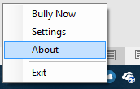

The About Form will open to display some basic information about this application

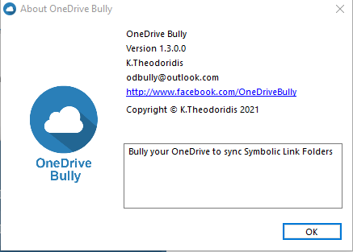

## Taskbar Icon

OneDrive Bully is a taskbar application. It doesn’t have a main interface.

After installation and setup, you can find the application in Start Menu

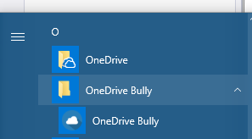

If you run the application, you will notice that a new taskbar Icon is displayed.



While the application is not processing anything, the icon will have a blue colour.

If you hover your mouse over the icon, a popup message will show you when is the next sync.



When the application is processing the changes, either on timer or on demand, the icon will change colour from blue to orange.



You will also notice that OneDrive icon shows that it is processing the changes.

If there are errors in your settings, OneDrive Bully taskbar icon will change colour from blue to red.



If you hover your mouse over the icon, a popup message will show you the error in settings.



## Sync on Demand

A feature that many would like to have in the standard OneDrive application is to force sync on demand. There isn’t any button or option to do this.

OneDrive Bully provides this ability by performing the above explained task whenever you double-click the icon or right-click and click Bully Now.

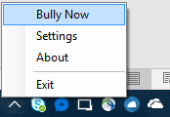

When OneDrive Bully is running the sync process, the icon will change to orange colour.

## Uninstallation

To uninstall OneDrive Bully, you can use the Windows Control Panel > Programs and Features >

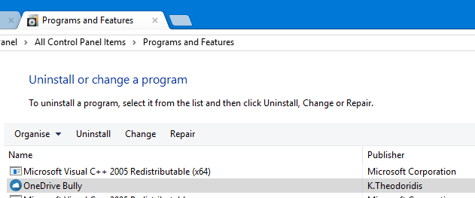

Click Uninstall and confirm.

# Special Thanks

I would like to personally thank the following websites and people for their useful blogs and code hints:

* <https://www.codeproject.com/articles/290013/formless-system-tray-application>
* <https://www.codeproject.com/Articles/70863/Hard-Links-vs-Soft-Links>
* <http://stackoverflow.com/questions/1220213/detect-if-running-as-administrator-with-or-without-elevated-privileges>
* <http://stackoverflow.com/questions/1485155/check-if-a-file-is-real-or-a-symbolic-link>
* <https://www.dotnetperls.com/datatable>
* <http://troyparsons.com/blog/2012/03/symbolic-links-in-c-sharp/>
* <http://www.iconarchive.com/search?q=cloud+sync>
* <http://stackoverflow.com/questions/5394098/how-to-make-an-exe-start-at-the-windows-startup>
* <http://www.sorrowman.org/c-sharp-programmer/save-user-settings.html>
* <https://www.visualstudio.com/vs/community/>

# Notes

OneDrive Bully and K.Theodoridis are not affiliated with Microsoft or OneDrive team.

The application is provided for Free. You will be able to download the GitHub project with the full Visual Studio Solution. Please check <https://www.facebook.com/OneDriveBully/> for news and updates.

The author acknowledges no responsibility of how you use the app and of your data integrity. Please do test syncs first with test folders and files to understand how it works, backup any OneDrive folder you will use with Symbolic Links and only if you are comfortable with it, use the app.

OneDrive Bully doesn’t work with Removable drives (flash drives, external hard drives) or Network folders. If OneDrive application fails to detect a Symbolic Link folder, it might crash and force you to reset your OneDrive settings.